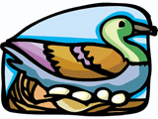  WANTED  A duck | 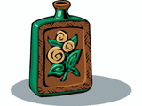  WANTED  A pottery vase | 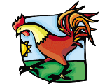  WANTED  A chicken | 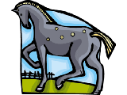  WANTED  A horse |   WANTED  Some eggs
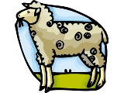  WANTED  A sheep | 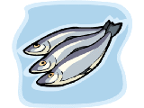  WANTED  Some fish | 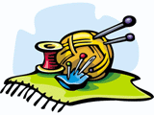  WANTED  Someone to make clothes | 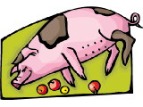  WANTED  A pig | 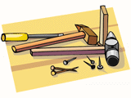  WANTED  Someone to build a barn

YOU OWN  A duck | YOU OWN  A pottery vase | YOU OWN  A chicken | YOU OWN  A horse | YOU OWN  Some eggs
YOU OWN  A sheep | YOU OWN  Some fish | YOU CAN  Make clothes | YOU OWN  A pig | YOU CAN  Build a barn

